LOW CODE
Zoho Creator
EXPERIMENT 7

NAME : ANIRUDH R ROLL NO : 240701039

USER ROLES AND PERMISSIONS

AIM
To implement role-based access control in the “Student Crop Advisory System” application in Zoho Creator by creating permission sets and roles, defining a data sharing rule, adding users, and verifying that the Administrator, Advisor and Student users can access only the components and records allowed for them.

SOFTWARE / TOOLS USED
- Zoho Creator (Low-Code Application Development Platform)
- Student Crop Advisory System application (created in Ex. 3)
- Web browser (Google Chrome / Microsoft Edge) with a normal window and an incognito / private window

THEORY
In Zoho Creator, a user is a person who can access an application. Access to the application components and to the data stored in them is controlled by User Permissions, which follow the Role-Based Access Control (RBAC) approach. User Permissions are made up of three parts: Permissions, Roles and Data Sharing.
- Permission set: A set of actions (such as View, Edit, Delete, View All and Modify All) that a user can perform on the forms, reports and pages of the application in live mode. Every user added to an application is assigned a permission set. Field-level permissions can also be set, for example to make a field Read Only for a user.
- Role and role hierarchy: A role represents the position of a person in the organization. When the role hierarchy is enabled, a user in a higher role can access the records added by the users in the roles below.
- Data sharing rule: Allows the records of a report to be shared from one user or role to another, even when the permission set alone would not allow it.
Only the super admin, admins and developers can create and manage these settings. Giving every user only the access needed for his or her work protects the data and prevents accidental changes.

ROLES AND ACCESS DETAILS
Three roles are created in the application “Student Crop Advisory System”. The role hierarchy is Administrator → Advisor → Student.

Role | Permission Set | Hierarchy | Purpose
Administrator | Administrator (default) | Top level | Manages the application, users and all data
Advisor | Advisor_Permission | Below Administrator | Views student queries and gives advisories
Student | Student_Permission | Below Advisor | Submits queries and reads advisories

The access given to each role is shown below:

Component | Administrator | Advisor | Student
Crop_Master form and report | Modify All | View All | View All (read only)
Student_Query form and report | Modify All | View All, Edit | Add, View and Edit own records
Student_Query – Status field | Editable | Editable | Read Only
Advisory form and report | Modify All | Add, Edit, View All | View only (data sharing)
Advisory Dashboard page | Access | Access | No access
Users and permission settings | Access | No access | No access

PROCEDURE
- Open the application: Sign in to Zoho Creator and open the “Student Crop Advisory System” application in edit mode. Note the forms, reports and the dashboard page available in the application.
Screenshot 1: Student Crop Advisory System in edit mode
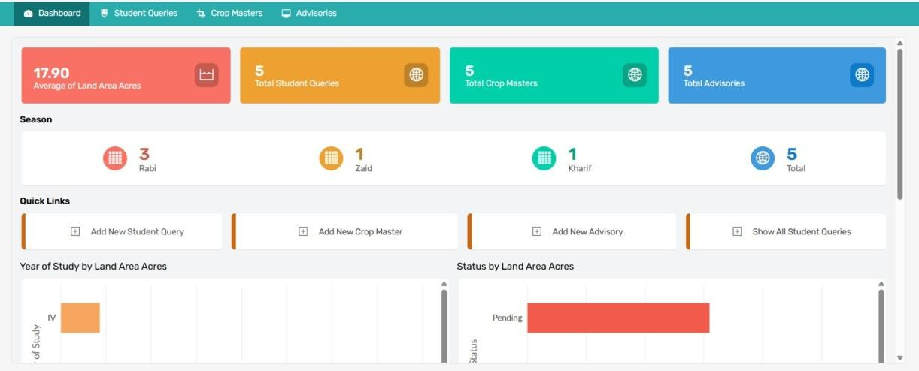

- Open the permission settings: Go to Users & Control (application settings) and open the Permissions page. View the default permission sets.
- Create the Student_Permission set: Click Add Permission Set, enter the name Student_Permission and a description. Give Add and View / Edit (own records) on Student_Query, View All on Crop_Master, View on Advisory, and remove access to the Advisory Dashboard. Click Save.

Screenshot 3:
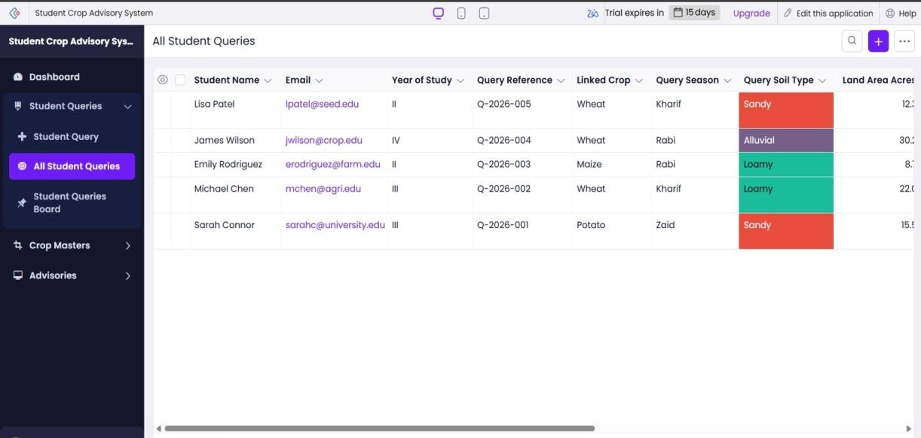

- Set the field permission: In the same permission set, set the Status field of the Student_Query form as Read Only, so that the student cannot change the status of the query.
Create the Advisor_Permission set: Add another permission set named Advisor_Permission with View All and Edit on Student_Query, Add / Edit / View All on Advisory, View All on Crop_Master and access to the Advisory Dashboard. Click Save.

- Create the roles: Open the Roles page and create the roles Advisor and Student. Arrange them as Administrator → Advisor → Student and enable the role hierarchy.

- Add a data sharing rule: Open the Data Sharing page and create a rule to share the records of the Advisory report from the Advisor role to the Student role with Read Only access, so that students can read the advisories.
- Add the users: Click Share (or Add Users), enter the email ids of the test users (one advisor and one or two students), select the role and the permission set for each user and click Share.

- Check the user list: Open the Users page and verify that every user is shown with the correct role and permission set.
- Test as Student: Open the application as the student user in an incognito / private window. Submit a query, and check that Crop_Master is view only, the Status field is Read Only and the Advisory Dashboard is not shown.

- Test as Advisor: Sign in as the advisor user. Check that all the student queries are visible, add an advisory for a query and open the Advisory Dashboard.

- Test as Administrator: Sign in as the application owner and verify that all the components, records and user settings are available.

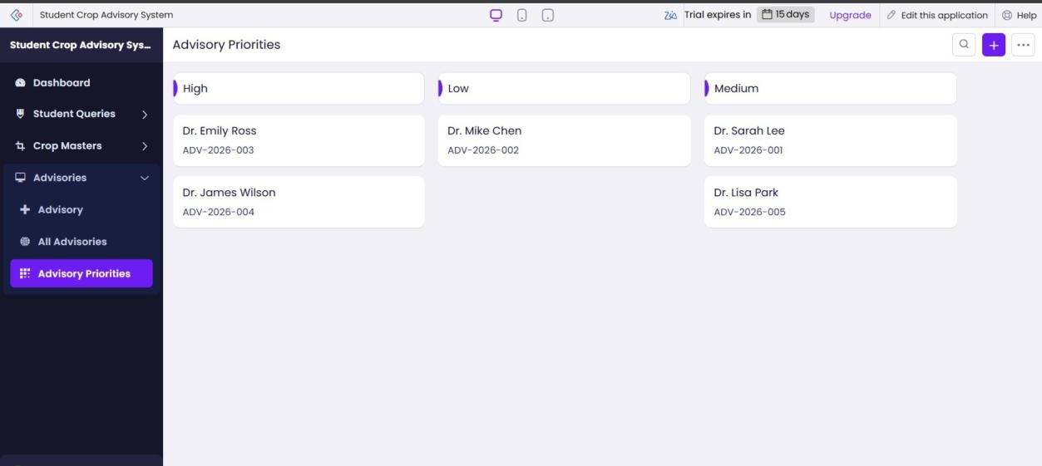

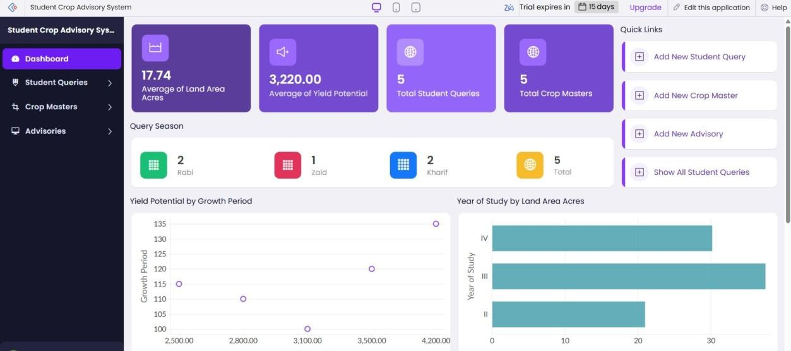

RESULT
Thus, permission sets, roles and a data sharing rule were created in the application “Student Crop Advisory System” in Zoho Creator, users were added with their roles, and it was verified that the Administrator, Advisor and Student users could access only the components and records allowed for them.

